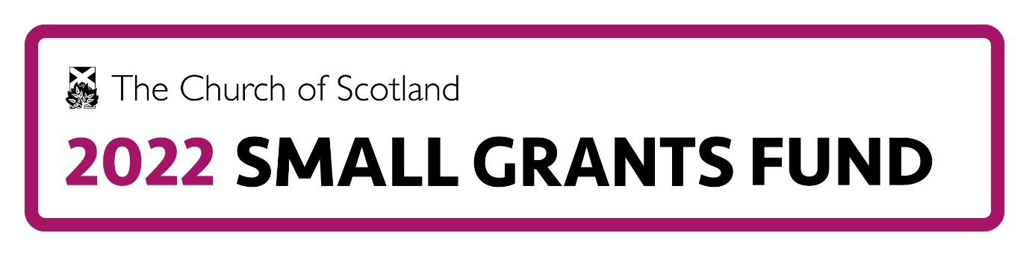
Guidelines for Applicants
Introduction
Often a small amount of money at the right time can make a huge difference. For this reason, the 2022 Small Grants Fund is focused on short-term projects of between 3 and 12 months rather than those which are larger and of longer scale.
Who can apply?
Only individual Church of Scotland churches and presbyteries, and groups of churches or presbyteries can apply but you can work with ecumenical partners.
How much can we apply for?
Grants will be up to £1,000 (max) allowing there to be 100 or more projects that can benefit from the fund (total grant budget £100,000).
Criteria for funded projects:
Projects will bring about change in at least one of the following areas:
- Developing mission through new worshipping communities (including online worship)
- Engaging and attracting those aged 40 and under including children, young people and families
- Addressing pressing issues in the church
- Increasing experimentation with innovation in church practices.
What can and cannot be funded?
- Awards are to be used with a revenue project focus
- Awards cannot be used for:
  - contribution to capital building costs
  - covering retrospective costs
  - making up shortfall in income.
How do we apply?
We strongly recommend that you use the Word template form (available from the Church of Scotland web site under the “Connect” tab in the “2022 Small Grants Fund” section or by emailing 2022SGF@churchofscotland.org.uk) to plan your draft before completing the online form as there will be no option to save your application and return to complete it later.
Match funding
There is no requirement for proof of match funding but projects can go beyond the funding provided by sourcing match funding. (“Match funding” is funding which is used to “match” the funding provided by a grant maker and comes from other sources.)
When can applications be made?
There are two “calls” for applications this year: April–June and September–November. Applications can be made during those periods and will be assessed on a rolling basis, in the order in which they are received via the online application form until the budget allocation is exhausted.
How quickly will awards be made?
We aim to make awards within 6 weeks of the date of application and these need to be spent within 12 months thereafter.
What is the Assessment Process?
Application forms will be considered by one of a panel of assessors drawn from Church of Scotland staff, volunteers and Presbytery Clerks. The assessment process will include a phone call with the applicant to gain further details of the project. A matrix scoring system to ensure that grants are assessed against set criteria has been developed. The Grants Manager will review these, seeking a commonality of approach, prior to the final award decisions being made by an award panel made up of the Grants Manager, Partnership Development and an Assembly Trustee.
Can my congregation/presbytery apply for more than one grant at a time?
Congregations can only hold one grant at any one time. Presbyteries can hold more than one but will need to demonstrate that they have the capacity to manage/oversee each one in their applications. If your congregation was successful in applying for a grant from the 2021 Small Grants Fund then you will need to have had your End of Project Review accepted before you can have an application considered in 2022. For further information contact 2022SGF@churchofscotland.org.uk
If the application is unsuccessful can we reapply?
Basic feedback on the application will be given in the notification of assessment letter and as long as the project is eligible you can amend your application and reapply at any time.
Support for applicants
On-line information sessions will be run with supporting information supplied on how to make an application to the Fund. We can answer questions about the form, however we cannot review draft applications. See the How to Apply section of the Small Grants Fund pages on the Church of Scotland site for dates of these sessions.
Supportive Network
To help the successful applicants we will be trialing an online group to allow projects to journey together and learn from each other as they implement their projects.
Reporting
Reports from projects are to be submitted within 1 month of completion (or no more than 12 months from time of award, whichever is the sooner. This simple written report will include a description of project, the beneficiaries (or those consulted if a research project), list of any partners and their involvement, intended outcomes/goals, achieved outcomes/goals, unexpected outcomes, key learning points and what the money was spent on. Receipts must be kept for possible inspection by the Fund.
Data Privacy
Note that the Privacy Agreement you will be asked to agree to when completing the online application form is available on the Church of Scotland 2022 Small Grants Fund web site.
Extract Minute
Applications will need to be accompanied by an uploaded, signed extract minute from their relevant church court covering all three of the following points:
- Supporting the application
- Agreeing with the General Conditions of Award
- Acknowledging that no other application can be made while this grant is current.
A sample extract minute is available from the Fund website.
If you have any further questions about the 2022 Small Grants Fund please send them to: 2022SGF@churchofscotland.org.uk

