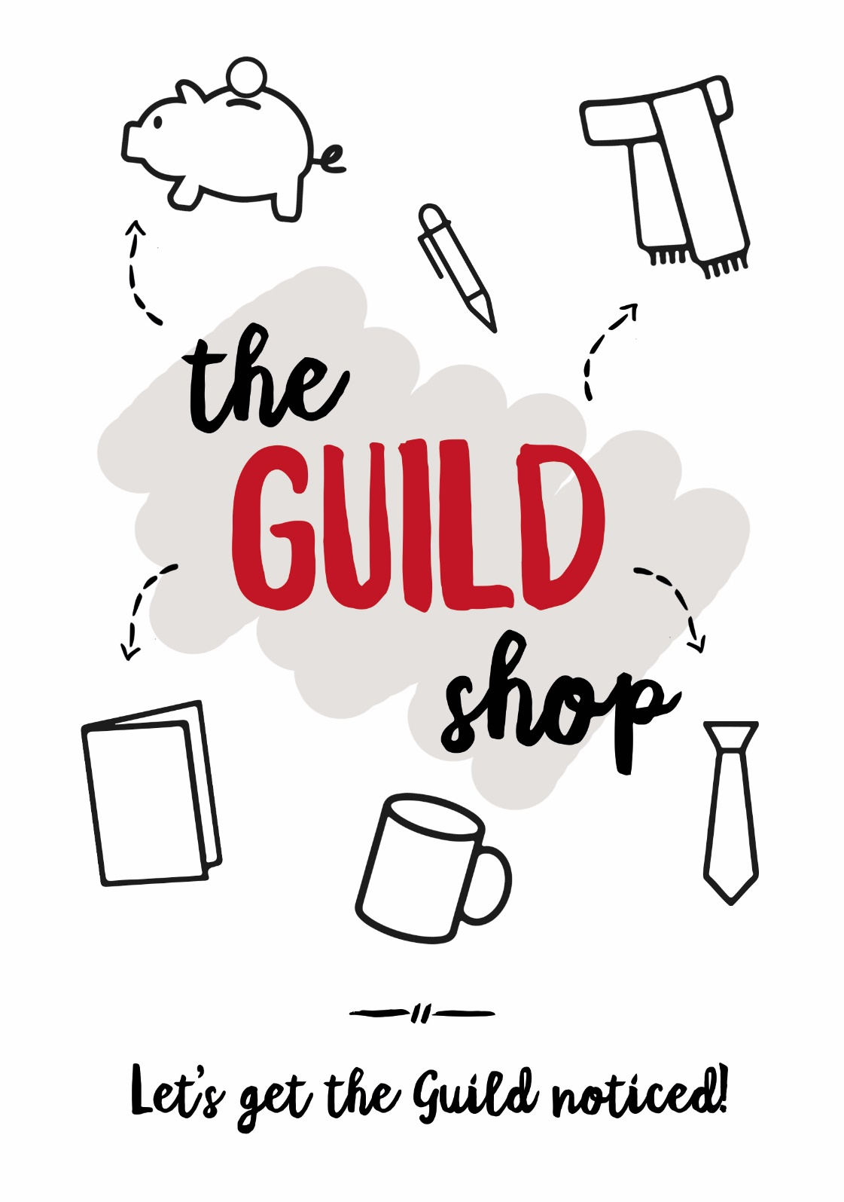

Description | Unit Price | Quantity/ Size | Cost
Guild tartan brooch with badge (limited supply) | £6.00
Guild tartan coin purse (special offer) | £6.00
Guild tartan spec case (limited) | £6.00
Guild Tartan lambswool scarf | £12.00
Guild Tartan lightweight scarf | £12.00
Guild Tartan shawl | £40.00
Guild Tartan stole | £30.00
Guild Tartan tie | £12.00
Guild 8oz tartan per ½ m | £15.00
Guild 12oz tartan per ½ m | £17.50
Guild Convener Badge | £3.50
Guilds Together Convener Badge | £3.50
Guild T shirts (S, M, L, XL) (special offer) | £4.00
Bunting (10m – tartan design) | £15.00
China mug | £5.50
Chocolate (assorted flavours) | £2.50
Diary (special offer) | £0.50
Greeting cards (6 pack) | £2.50
Guild Fleece (S, M, L) | £15.00
Hand Sanitiser | £1.50
I love the Guild mug (Special offer) | £2.00
Iron on transfer | £1.50
Jute Bag (special offer) | £4.00
Logo badge | £3.00
Lens cloth | £2.00
Logo stickers (strip of 5) | £0.60
Luggage Tags (special offer) | £1.00
Mobile Phone Sock | £1.00
Mystery Bag worth £15 | £10.00
Pen (red) | £1.00
Pen (gift boxed) | £3.00
Pencil | £0.50
Post it Magnet | £1.00
Oven glove (special offer) | £5.00
Remembrance card (10 pack) | £6.00
Serviettes (100 pack) | £3.00
Speakers Exp. Env. (10 pack) | £1.00
Spiral Notebook | £2.50
Sterling silver earrings | £75.00
Sterling silver pendant | £85.00
Sterling silver charm | £40.00
Thank You Cards (6 pack) | £2.50
Travel mug (special offer) | £2.00
Window sticker (special offer) | 75p
Resources Order Form
Description | Unit Price | Quantity | Cost
Wee Seeds, Big Trees  Theme and Discussion pack | £5.00
Constitution and Guidelines | £1.50
Big Book of Gui(l)d ideas | £5.00
Total

Complete in capitals
Name
Address
Postcode
Telephone
Please note that shawls and stoles have a 2 week order time, the sterling silver items a 4 week order time.
Postage and Packing will be added by Guild Office. Please DO NOT send cash or cheques as we will enclose an invoice with your order.

