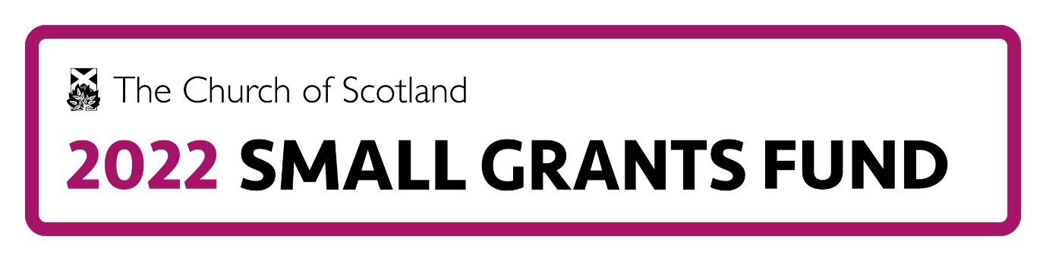
Application Form
Before you complete the online form please note the following:
- Only Church of Scotland congregations and presbyteries are eligible to apply for this fund but it is also possible to work with ecumenical partners
- Applications can only be accepted via the online form but please use this Microsoft Word template to plan your draft before completing the online form as there will be no option to save your application and return to complete later
- Ensure that in completing the form you have referred to the 2022 Small Grants Fund Guidance Notes
- At the end of the form you will need to upload a signed extract minute from the relevant church court supporting the application, indicating acceptance of the General Conditions of Award and acknowledging that no other application can be made while this grant is current. You can download a model minute from the Church of Scotland Small Grants Fund site.
- By completing the application form, the person completing and submitting it is undertaking that they have permission to disclose to us, and that we have permission to disclose to any third parties we may instruct for the purposes of administering the application and any grant, all of the personal data included in the application form. Personal data is any information that can be used to identify a living person.
- We are contracting with SCVO for the purposes of administering the grant platform web site and grant-related processes.
- Personal data that we, or any third parties instructed by us, process for the purpose the 2022 Small Grants Fund is processed on the basis of fulfilment of an agreement with you to process grant applications forms and to facilitate grants that are awarded. Links to The Church of Scotland and SCVO Privacy Notices can be found at the bottom of the online form.
- If you have any questions about this form or any other aspect of the 2022 Small Grants Fund please send them to: 2022SGF@churchofscotland.org.uk
Q1. Please tell us how you heard about the 2022 Small Grants Fund.

Q2. Please enter the full Scottish Charity Number beginning with 'SC' then six digits of the church/presbytery making this application: (search the OSCR register if you need to find your number)
Scottish Charity Number:
Organisation type:
Organisation name:
Q3 Organisation Address Please enter the organisation’s main address in Scotland (this will be pre-populated if you completed your Scottish Charity Registration number – but can be over-written if required)
Street:
Town/city:
Local Authority:
Postcode:

Q4. Organisation Bank Account Details
To increase the speed of making payments to successful applicants, we are asking for your organisation’s bank details at this stage.
Account name:
Account number:
Sort code:
Bank name:
Bank address:
Bank postcode:

Q5. Presbytery name/number:
Q6. Name of Project
Q7. Give us the names of two people (not related to each other) connected to the project in your organisation who we can contact Please note all correspondence will be sent to the first named contact:
Primary contact (you):
First name:
Last name:
Position or Role in the church/project:
Primary phone number (Please give us the best number to reach you on, this number will be used to call you as part of the assessment process):
Alternative phone number:
Email address:

Contact 2:
First name:
Last name:
Position or Role in the church/project:
Contact phone number:
Email address:
Q8. For how many months do you intend this project to run?

Q9. Please describe who will benefit from this project and what are the reasons you want to work with them. (200 words max)

Q10. What difference do you hope to make for them through this project? (200 words max)

Q11. What do you intend to do? (200 words max)

Q12. Select which of the 2022 Small Grants Fund criteria the project fits with and describe how it fits.
Projects will bring about change in at least one of the following areas:
- □ Developing mission through new worshipping communities (including online worship)
Describe how your project fits this criterion (max 50 words)

- □ Engaging and attracting those aged 40 and under including children, young people and families
Describe how your project fits this criterion (max 50 words)

□ Addressing pressing issues in the church.
Describe how your project fits this criterion (max 50 words)

□ Increasing experimentation with innovation in church practices.
Describe how your project fits this criterion (max 50 words)

Q13. Please provide a breakdown of project costs and where the money will come from by completing the following sections. (Maximum of £1000 from the 2022 Small Grants Fund per applicant)
Please enter a detailed budget of the elements/items required for the project:
Description | Amount
Total

Please enter the sources of funding to cover the above:
Source | Amount
2022 Small Grants Fund (£1000 max)
Total (must be same as budget amount in above table)

Q14. Monitoring and Evaluation. How will you measure what you are doing and use this information to demonstrate the impact of this project? (max 100 words)

Q15. How will the project be managed to ensure good practice throughout? (max 100 words)

Q16. Keeping everyone safe
What steps will you taken to keep people safe (including yourself and your volunteers/staff) and follow NHS, Government, Food Standards agency and other relevant guidelines? (max 100 words)

You will need to upload a completed, signed extract minute from your church court: (kirk session or presbytery as appropriate) which supports the application, accepts the General Conditions of Award and acknowledges that it is ineligible to apply to the 2022 Small Grants Fund for any other project, until any funding awarded had ceased.

Confirmation:
□ I declare on behalf of ………………………………………………. that the information I have provided is true and accurate to the best of my knowledge.

