SALVAGE GRAB SHEET

ITEM LOCATION: Main Sanctuary, display cabinet adjacent to pulpit.

ITEM: Communion Silverware, Goblet. | PRIORITY: High
INVENTORY NUMBER: 008

WEIGHT: Light – 1 Person needed to carry | REMOVAL: Open display cabinet, carry by stem and supporting the base of the goblet
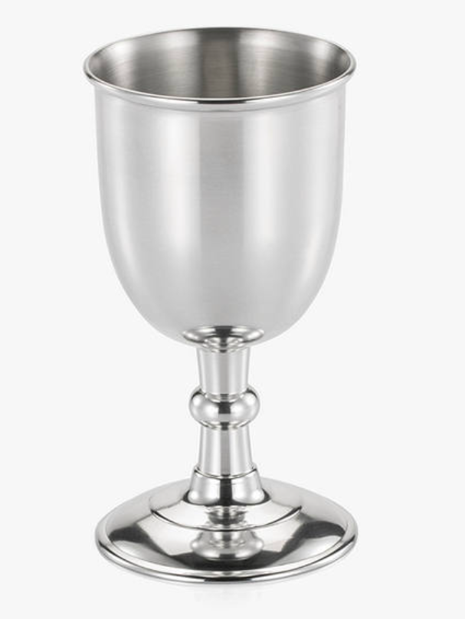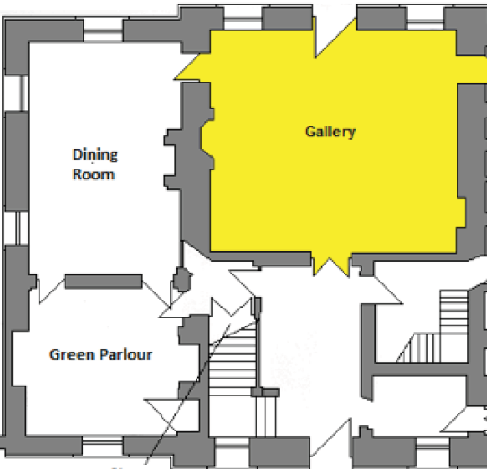
Sanctuary
Foyer
Choir Room
Vestry
20cm
8cm

EMERGENCY STORAGE LOCATION: Church hall

ADDITIONAL INFO:

