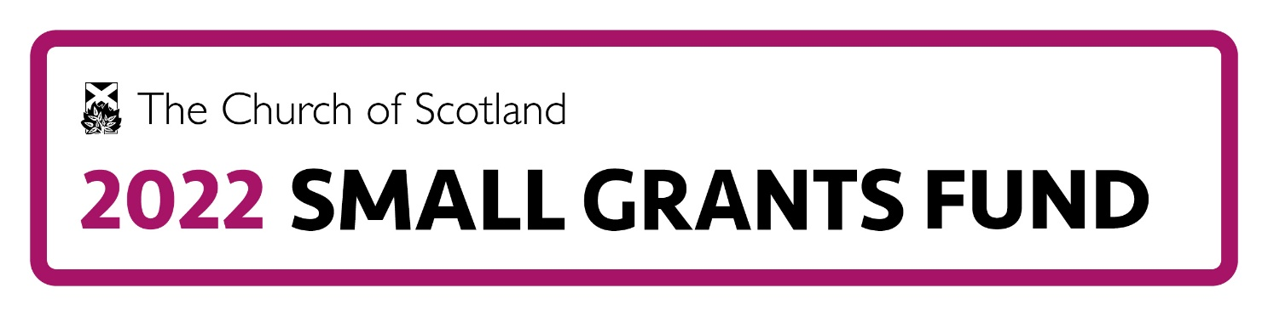
GENERAL CONDITIONS OF AWARD
- Grants must be used for the purpose stated in the letter of award. Any significant change in local circumstances affecting the aim of the work and the use of the grant should be discussed in advance with the staff of the Church of Scotland 2022 Small Grants Fund. Staff can be contacted via email at: 2022SGF@churchofscotland.org.uk
- Organisations are not eligible to apply for a further grant while in receipt of one.
- Grant monies must be spent within 1 year of payment.
- Recipients must acknowledge the support of the Church of Scotland 2022 Small Grants Fund in annual reports and project leaflets/distributed information. The 2022 Small Grants Fund logo will be provided for this use.
- Relevant receipts should be available to the Church of Scotland 2022 Small Grants Fund to view on request.
- Recipients must report to the staff of the Fund on progress of the work and account for the use of the grant within 1 month of the completion of the project.
- The Church of Scotland 2022 Small Grants Fund reserves the right to use news and information about your project on the website and in promotional materials about the fund.
- Any equipment purchased with a grant should be satisfactorily maintained and insured.
- If the work comes to an end the unused balance of any grant must be returned to the Fund, and you must consult with the staff of the Fund about the future use of equipment purchased with a grant from the Fund.
- You must keep us informed by email of any changes in the main contacts, or their details.
- Further conditions in relation to specific projects may be set by the Church of Scotland 2022 Small Grants Fund.
- Failure to comply with these conditions of award may result in any agreed funding being withheld, or in the Fund being entitled to recover from the organisation any grant already awarded.
Safeguarding
- Organisations must demonstrate that all statutory obligations have been complied with and that appropriate policies and procedures are in place for the protection of children and vulnerable adults.
- Relevant records should be available to the Church of Scotland 2022 Small Grants Fund to view on request.

