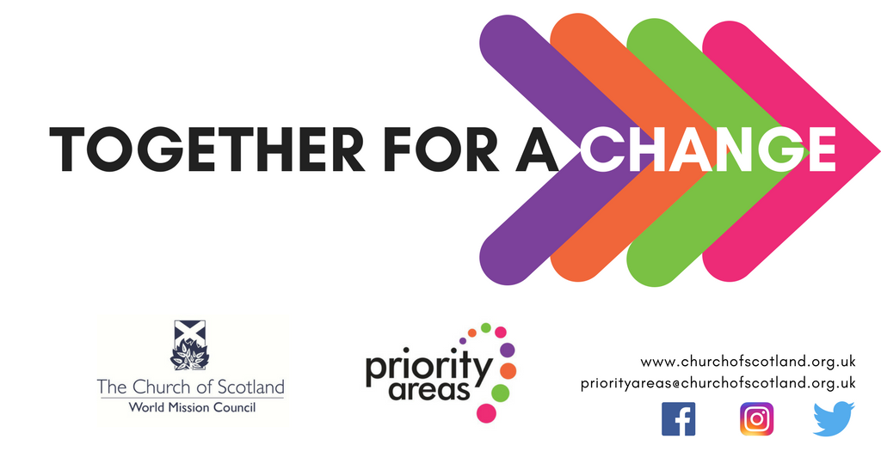
Together for a change is a partnership between Priority Areas and World Mission. It exists to help individuals from Priority Area communities engage in exchanges with World Mission partner Churches around the world to further the aims relating to individual growth, community development, and tackling poverty.
Please run through the checklist in the guidance notes before spending time completing this application form. Read the notes carefully and refer to them as you complete the form.

Who will be involved from your community?
Click here to enter text.

Who will you partner with Internationally?
Click here to enter text.

What will your partnership do?
Click here to enter text.

Why? What differences do you want to make?
Click here to enter text.

Outcomes - These are the differences we want to make as a result of the TFAC project: Describe how your piece of work will fit in with any of these outcomes?
- Going beyond the edges of our own experiences to find transformation.
- Empowering individuals through challenging experiences and new connections.
- Building relationships for the transformation of community and growing resilience through shared experience.
- Experiencing life in another culture to enable participants to tell a body of new stories about themselves and the world.
- Exploring the roots of poverty within two cultures to enable change.

Click here to enter text.

What kind of information will you gather as evidence of how successful you have been in meeting these outcomes?

Click here to enter text.

Checklist:
☐ Budget Sheet Included
☐ Kirk Session Minute of support included

